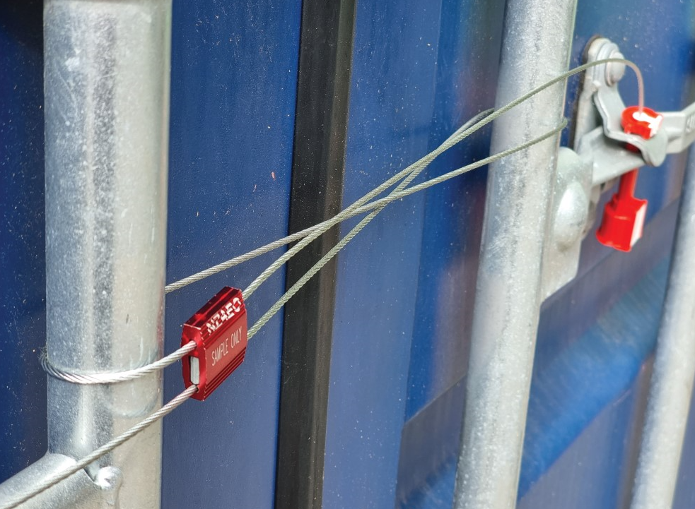
We will work together to ensure your supply chain is secure.
SES Partners must report relevant security incidents to Customs.
Breaches or incidents may include:
- SES sealed container found to be tampered with
- Unauthorised goods found within the container
- Site break-ins affecting the security of restricted areas
- Suspicious or unusual documentation
- Cybersecurity attack that affects your supply chain.
For more information
Freephone: 0800 4 CUSTOMS | 0800 428 786 (24/7)
Email: ses@customs.govt.nz

